Storytelling

1-Rana AL Saey:
When Passion Becomes a Defining Mark Since childhood, Randa El Saey has found her happiness among colors and threads, crafting beauty with her hands and weaving dreams with her imagination. Although she studied at the Faculty of Commerce instead of Fine Arts, her love for handicrafts never faded. She began her journey by learning crochet and tapestry, mastering both and later training young women to perfect these crafts. Her passion didn’t stop there. Randa continued exploring and learning new arts such as quilting, patchwork, embroidery, and fabric painting, searching for a way to merge all these skills into one creative expression that carried her personal touch. That’s when she discovered natural leather — a material that could beautifully blend with fabric, crochet, and other handmade arts. Determined to learn from the source, she went to Bab El Shaariya in Cairo to study the fundamentals of leather crafting, taking her first real steps into the world of handmade bags and wallets. During the lockdown period of the COVID-19 pandemic, Randa used her time to refine her craft, following international artists online to master the details of finishing and professional design techniques. By the end of 2020, she launched her own brand, and her very first product — a men’s wallet featuring embossed detailing — received great feedback from her first client, encouraging her to keep going. In 2022, Randa’s project was selected among the top five finalists in a business incubator program organized by the Ministry of Industry and the Academy of Scientific Research, after which her brand was officially registered. Today, Randa proudly owns Rano, a handmade leather goods brand that represents more than just craftsmanship — it’s a story of passion that began with a thread and a needle and grew into a dream crafted with heart and hand.

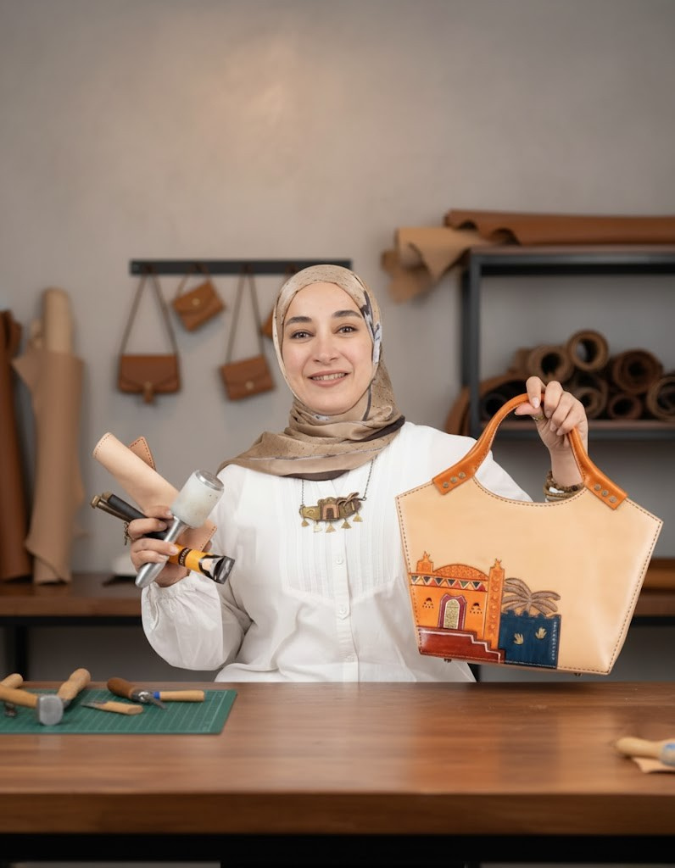

2-Asmaa Omran:
Asmaa Omran – Founder of the brand “Ibnat Omran\ the daughter of Omran”
A 2007 graduate of the Faculty of Commerce, Cairo University, my creative journey in the world of handicrafts began after studying techniques and design in Bab El Shaaria in 2019. My own brand, “Ibnat Omran,” was established in 2021, specializing in natural leather products. My work combines authentic Egyptian heritage with modern designs, showcasing my expertise in hand-carving, embossing, and burning techniques on leather.

I have participated in numerous exhibitions, including the Cairo International Leather Fair, and have completed several courses in marketing and artificial intelligence. I also continue my studies in various art forms and drawing techniques using all available materials.
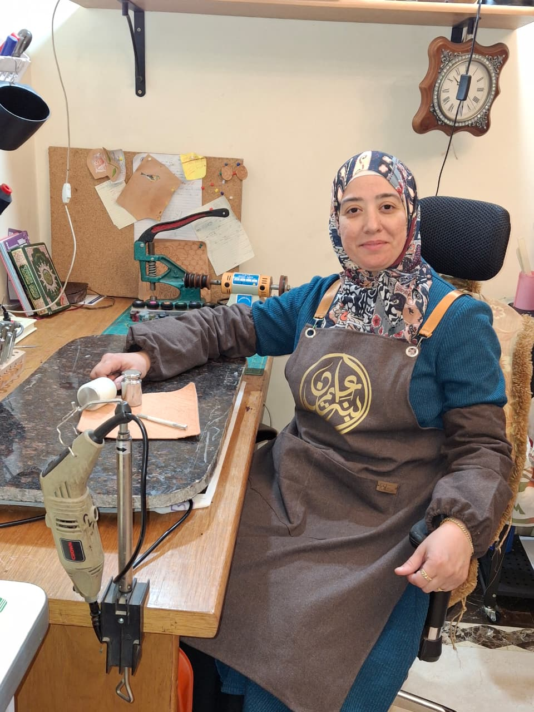
3-Shiraz Magdi:

inspired by the richness of Egyptian artisanal heritage, Shiraz embraces natural leather as a timeless material, shaping it with a contemporary artistic vision to tell stories of culture, passion, and identity. Shiraz is a luxury handmade leather goods brand founded by Shiraz Magdi — a visual artist and passionate interior designer with a deep love for traditional craftsmanship and natural materials. The journey began in 2017, when Shiraz participated in a visual arts exhibition using natural leather for the first time. Captivated by the elegance and sophistication of the material, she immersed herself in learning leather-craft techniques — from cutting and perforating to hand-stitching — eventually setting up a small workshop fully equipped with artisanal tools, and creating her first hand-woven leather bag. This marked the birth of Shiraz, a brand that continues to evolve with passion, creativity, and an entrepreneurial spirit. Today, Shiraz remains committed to crafting timeless leather pieces that combine artistic expression, meticulous craftsmanship, durability, and elegance — products designed to accompany their owners for a lifetime and reflect their distinctive taste and character.

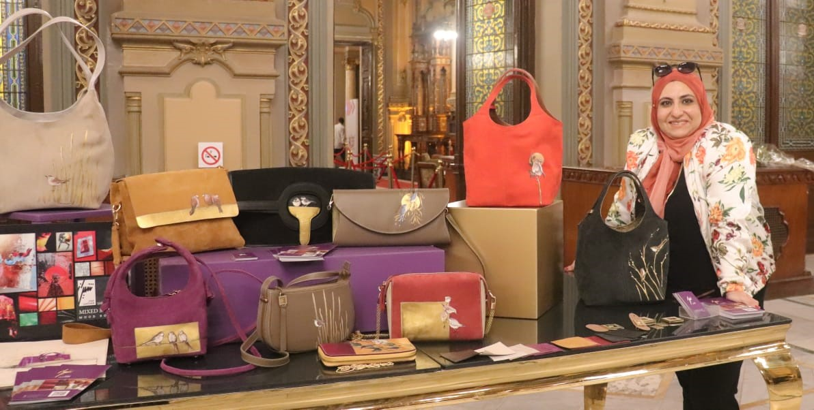

4- Susan Gamal:
Certified entrepreneurship and idea generation trainer for artisans from the American University in Cairo, the National Council for Women, and the United Nations. Also a trainer in the craft of manufacturing natural leather products at cultural centers and the National Council for Women, focusing on the economic empowerment of women and youth. A professional designer using various design software. A member of the General Assembly of the Handicrafts Chamber at the Federation of Egyptian Industries. A member of the "Creativity in Egypt" initiative, sponsored by Bank of Alexandria and the Sawiris Foundation for the development of handicrafts.

A member of the National Council for Women's initiatives in Cairo for women's development and economic empowerment.
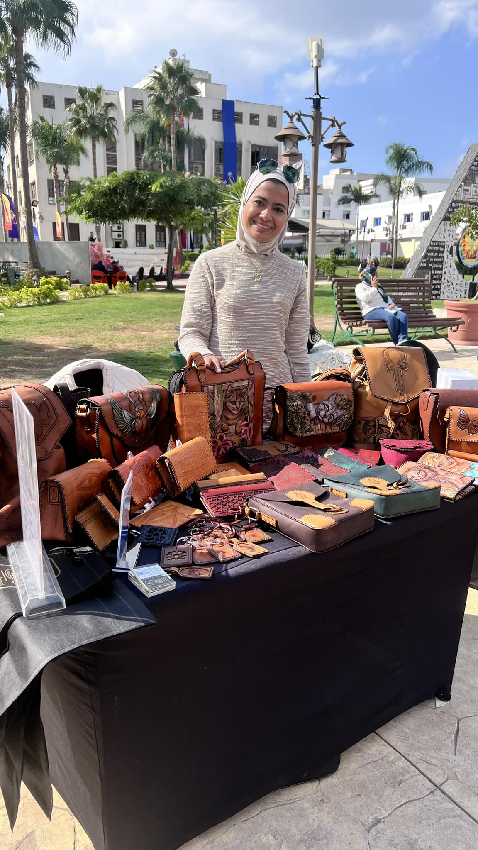

5-Sahar Mahdy:
An internationally certified trainer accredited by the Science and Technology Authority and the European Quality Organization. A professional natural leather designer specializing in the design, execution, and drafting of natural leather patterns, manufacturing, and training in all related techniques, including burning, drawing, engraving, cutting, pricing, and assembling natural leather.
